

Professor:wang fang

Student: Hind El kettani

04

HC/D issues and data structures

04. Abstract
04.1 Introduction
04.2 Huffman Algorithm ( coding/decoding)
04.3 Data structures and Huffman Algorithms
04.4 Briefly introduce the purpose of the project
04.5 Implementation Requirements: Initialization (Function 1), Coding (Function 2)
Decoding (Function 3), Building Huffman Tree(Function4)
Flowchart of the program
04.6 Implementation Tips: Modular Design, Menu Mode, Disk File Data Handling
04.7 Implementation Details
04.8 Conclusion
Hind EL kettani
Dalian polytechnic university
04 Abstract :
This research focuses on the implementation and optimization of Huffman encoding in order to improve the efficiency of information communication. The project's goal is to enhance channel utilization, reduce transmission time, and minimize costs by using Huffman trees and data structures. The study looks on efficient Huffman tree construction techniques for increased compression efficiency, as well as dynamic Huffman coding scenarios for flexibility to changing data frequencies. It also investigates error detection and correction strategies to improve Huffman coding/decoding resilience. The use of the Huffman algorithm in this methodology has produced encouraging results, including increased compression efficiency, robust adaptation to dynamic settings, and improved error resilience. This study makes a substantial contribution to the area by emphasizing the practical consequences and importance of data compression and encoding in real-world applications.
04.1 Introduction :

Huffman coding is a powerful technique in data compression that allows for efficient representation of information. It addresses the challenge of minimizing the number of bits required to transmit data while preserving its content. Developed by David A. Huffman in 1952, this algorithm has had a significant impact on the field of computer science and information theory .
The fundamental idea behind Huffman coding is to assign variable-length codes to input characters based on their frequencies within the given data. By assigning shorter codes to more frequent characters and longer codes to less frequent ones, Huffman coding optimizes space utilization and reduces transmission costs .
In practical terms, let's consider a scenario where we want to send four letters: A, B, C, and D. Directly transmitting these letters would be inefficient since each letter is represented by 8 digits in computers. However, through encoding principles like Huffman coding, we can represent these letters more compactly .
For example, we can encode A as 00, B as 01, C as 10, and D as 11. If we need to transmit 10 A's, 5 B's, 3 C's, and 2 D's using this encoding scheme, the total number of bits required would be calculated as follows: (10 × 2) + (5 × 2) + (3 × 2) + (2 × 2) = 40 bits .
The problem tackled by Huffman coding is crucial in the field of data representation techniques within computer science. Huffman's work marked a critical milestone in developing efficient ways to represent information . Since its publication in 1952, Huffman's seminal paper has received over 7,500 citations and has greatly influenced compression and coding regimes used today in various applications such as digital cameras ,music players ,software distribution tools ,and document archiving systems .
By understanding the principles of Huffman coding and its significance in data compression, we can explore how to implement this algorithm efficiently. This project involves tasks such as initialization, coding, and decoding using a built Huffman tree. The implementation should include functions like reading the character set size, characters themselves, and their weights from the terminal; establishing the Huffman tree; encoding text using the tree; and decoding encoded data .
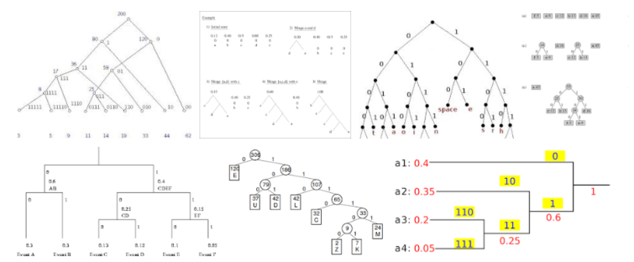
Fig. 1. A small section of the search result page returned for the query “Huffman code” at Google Image Search, captured as a screen-shot on 5 August 2018. The full result page contains approximately one thousand such images
1.1 Huffman coding concept
. Huffman's idea is - with the benefit of hindsight - delightfully simple. By assigning variable-length codes based on probabilities, Huffman coding achieves efficient data compression and optimal code representation . This adaptive encoding scheme allows for the reduction of overall encoded data length by assigning shorter codes to frequently occurring variables and longer codes to less frequent ones.
In traditional encoding methods, fixed-length codes are assigned to each variable regardless of their probability of occurrence. However, Huffman coding takes a different approach by constructing a Huffman tree or prefix tree. This binary tree is built by analyzing the probabilities or frequencies of each variable and assigning shorter codes to those with higher probabilities.
During decoding, the same Huffman tree is used to map the variable-length codes back to their original values. The simplicity of Huffman's idea lies in its ability to adaptively encode data based on its statistical properties, resulting in efficient compression without loss of information.
Huffman coding has found widespread use in various applications where efficient data storage and transmission are crucial. Its elegant simplicity and effectiveness make it a fundamental technique in the field of data compression.

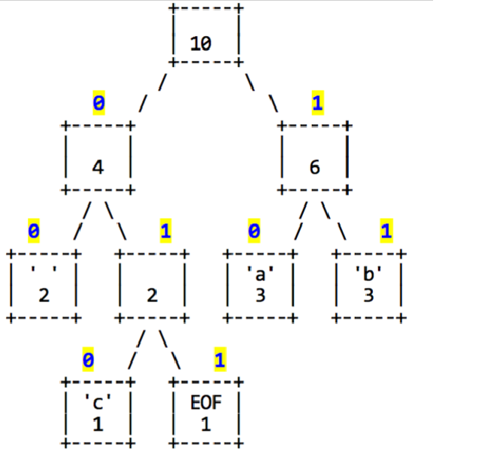
fig 2.exmple about Huffman tree

The Huffman coding and decoding project aims to develop a program capable of performing Huffman encoding and decoding based on a given character set and their frequencies. This involves constructing an optimal Huffman tree that minimizes the overall encoded message length. The objective is to apply Huffman coding to achieve efficient compression by assigning shorter codes to more frequently occurring characters. The project includes implementing file input/output operations for reading and writing data, such as reading the character set, weights, and statistical data from files, as well as saving the Huffman tree and encoded/decoded data. Dynamic Huffman coding is provided, allowing the program to update the Huffman tree based on actual statistical data of the character set and frequency. A menu-driven user interface is designed to allow users to interact with the program, selecting different operations such as initialization, coding, and decoding. Efficient data structures, such as a Huffman tree, are implemented and used to represent the encoding scheme. Proper memory management techniques should be employed for dynamic construction of the Huffman tree.
Error handling and robustness are essential for maintaining the program's stability and reliability. Incorporating error handling mechanisms ensures that potential issues such as invalid input or file read/write errors are appropriately handled. Robustness is essential to maintain the program's stability and reliability.
The project will utilize several data structures:
1. Huffman Tree: A binary tree where each leaf represents a character, while internal nodes represent merged characters based on their frequencies. Each node in the Huffman tree contains information about a character (or a group of characters) and its frequency.
2. Priority Queue (Min Heap): Used during tree construction to efficiently select nodes with the lowest frequencies, facilitating optimal tree construction.
3. File I/O: Crucial for reading and writing data related to character sets, weights, encoded data, statistical information, as well as saving/loading the Huffman tree itself.
5. File System: A structure designed for implementing a menu-driven user interface, allowing users to interact with the program and select different operations easily.
By successfully implementing Huffman coding and decoding in this project, developers can gain valuable insights into data compression techniques, efficient information representation, file handling operations, dynamic tree construction, error handling mechanisms, and documentation practices.
This report aims to provide an understanding of the implementation process for Huffman encoding, including initialization, coding, decoding functions, as well as building a Huffman tree based on statistical data.
In conclusion in this report we will be implementing encoding and decoding for the message "This Program IS MY FAVORITE."
04.2 Huffman (coding /decoding) :
D.A. Huffman developed on how to reduce the binary bit length necessary for character encoding in a communications system in 1952, and it is now used to construct pre-dimensional coding techniques with limitless lengths.As shown in the preceding example, the basic idea of the pre-level encoding algorithm is that for the appearance of more likely words, the course encoder method will be used, while for the appearance of less likely characters, the long encode method will be used. Huffman's proposed algorithm can make the WPI value of the fork made the minimum, ensuring that in the communication process, the transmission of the total length of the binary mode is optimized, which is the main, sequence) produced the same optimal fork tree .This process is commonly referred to as the Huffman algorithm, and the optimal binoculars are referred to as the Huffman tree. The Huffman tree's specific structural algorithm is given below.
(1) Using the specified value of m (www), which is a collection of m forks T=1 T:......T), where T is the root point and its right subtree is empty.
(2) The value of two root points chosen from T.The smallest binoculars can be set as TT, and as right form a new binocular T, and put the root value of the new binocular to the sum of the weight of the root point of its right subtree.
(3) the new binicular T to the original binocular T.
(4) Repeat (2) and (3) until only one tree remains out of the seven. The Harfman tree is its name.
1.2 Decoding by using tree.
The fixed-length tree is an efficient method for decoding Huffman-encoded bits. By starting at the beginning of the bits and at the root, the path-following strategy is used to trace the bits to the left, right, and then to the 'y' leaf. This method is effective for decoding the stream of bits 011101010010011. The Huffman tree also uses this strategy, starting from the root and tracing down to the left to hit the 'y' leaf, then a left-left-right path to the 'i' leaf. Despite the encoded characters not starting and ending at evenly spaced boundaries, the decoded string is "yippy".
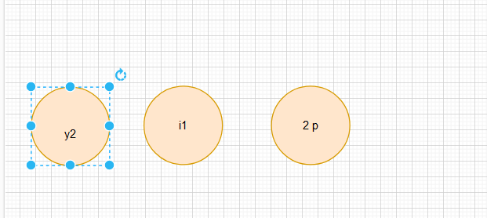
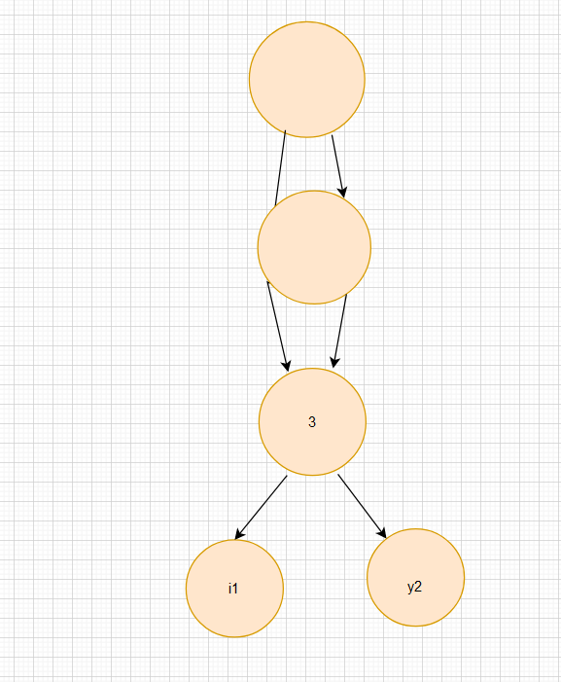
Fig. Huffman tree using B-tree
The Huffman tree is a data compression technique that efficiently encodes and decodes data by assigning shorter codes to more frequent characters and longer codes to less frequent ones. It stores nodes in a priority queue structure, allowing for efficient insertion and removal based on their frequencies. The merge Nodes function merges two nodes with the lowest frequencies into a single node, yielding the root of the Huffman tree .The calculate Character Frequencies function computes the frequencies of each character from an input string, whereas the build Huffman Tree function constructs a Huffman tree from the input string. The getCharacterEncoding method assigns '0' to each node's left child and '1' to its right child. The encode Data and decode Data functions use the character set to encode and decode the input string.
04.3 Data Structures and Huffman Algorithms
Data structures play a crucial role in Huffman coding decoding, a process that efficiently reconstructs original data from encoded form. The main data structure used is the binary tree, also known as the Huffman tree or prefix tree. The tree is constructed during the encoding phase and used during decoding to map variable-length codes back to their corresponding characters. Each node represents either a character or an internal node that serves as a branching point for different code paths.
Data structures involve building the Huffman Tree, traversing the Huffman Tree, and mapping codes to characters. The system uses priority queues to efficiently merge nodes and construct the optimal binary tree structure. As bits are traversed through the Huffman tree, they form a path from root to leaf nodes, which correspond to specific characters and hold their respective codes.
By utilizing efficient data structures like priority queues and binary trees, decoding algorithms can navigate through encoded data with minimal time complexity. The hierarchical structure of the Huffman tree allows for quick mapping between codes and characters during decoding operations. Overall, data structures play an essential role in facilitating efficient navigation and retrieval of information during Huffman coding decoding processes.
In summary, data structures are integral to the efficiency and effectiveness of Huffman coding and decoding. They facilitate the organization of information, enable efficient traversal of the Huffman tree, and provide a means for managing and manipulating data during the compression and decompression processes.
04.4 Briefly introduce the purpose of the project
The goal of this report is to define the prerequisites for implementing a Huffman coding scheme. Huffman coding is a data compression technique in which characters are assigned variable-length codes based on their probabilities or weights. The system intends to optimize channel utilization, shorten information transmission time, and lower transmission costs by employing this encoding approach .Also to show the importance of data structures ,this system have this following mian function Initialization,coding/decoding, Build Huffman Tree with Statistical Data

04.5 Implementation Requirements :
Flowchart of the program :

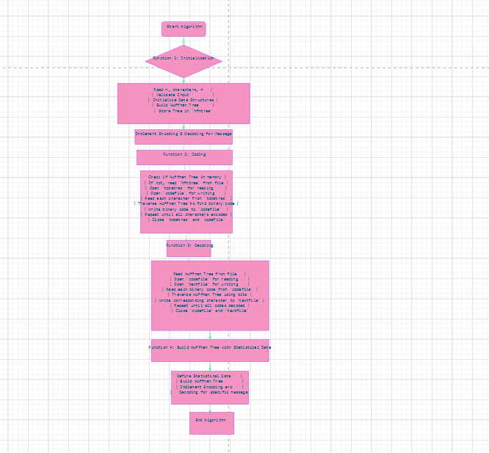

ALGORITHMS OF THE PROJECT:
Function 1: Initialization
1. Read character set size (n), n characters, and m weights from the terminal.
2. Validate user input to ensure it meets the required criteria.
3. Initialize data structures for storing characters and weights.
4. Build a Huffman tree based on the input character set and weights.
5. Store the Huffman tree in the 'hfmtree' file.
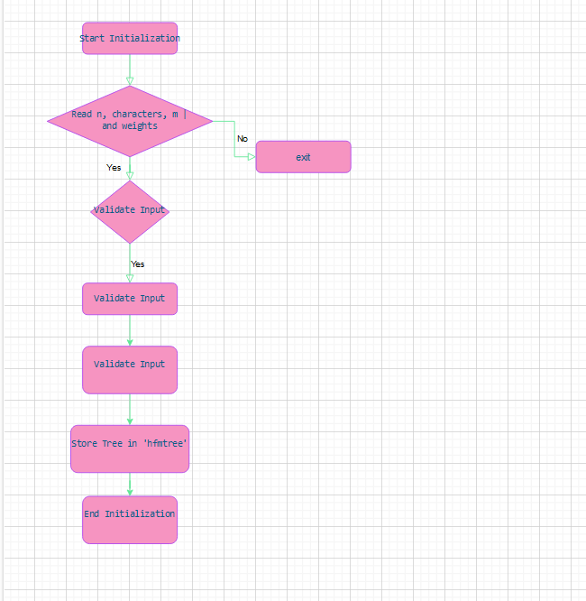

Function 2: Coding
1. Check if the Huffman tree is in memory.
2. If not, read the Huffman tree from the 'hfmtree' file.
3. Open 'tobetras' file for reading and 'codefile' for writing.
4. Read each character from 'tobetras' file one by one.
5. Traverse the Huffman tree to find the binary code corresponding to each character.
6. Write each binary code obtained to the 'codefile'.
7. Repeat steps 4-6 until all characters in 'tobetras' have been encoded and written to 'codefile'.
8. Close both files ('tobetras' and 'codefile').
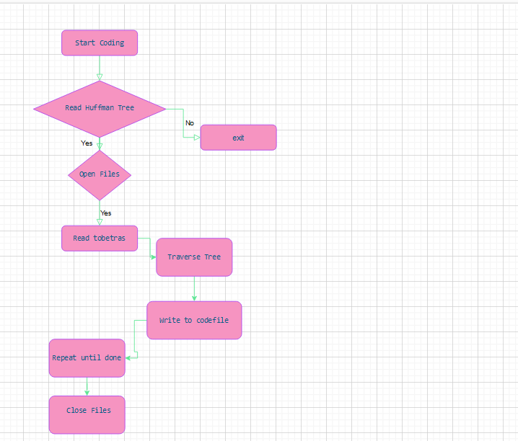

Function 3: Decoding
1. Read the Huffman tree from the 'hfmtree' file into memory.
2. Open 'codefile' for reading and 'textfile' for writing.
3. Read each binary code from 'codefile'.
4. Traverse the Huffman tree using each bit of binary code until a leaf node is reached.
5. Write the corresponding character to 'textfile'.
6. Repeat steps 3-5 until all codes have been decoded and written to 'textfile'.
7.Close both files ('codefile' and 'textfile').
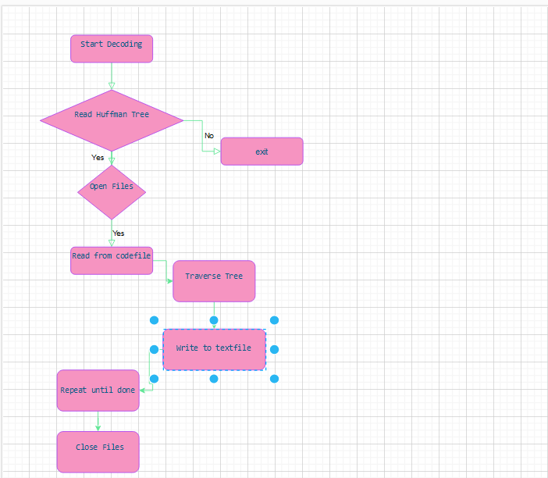

Function 4: Build Huffman Tree with Statistical Data
1. Define the statistical data for the character set and frequency.
2. Build a new Huffman tree using the statistical data.
3. Implement encoding and decoding for the specific message "This Program IS MY FAVORITE".
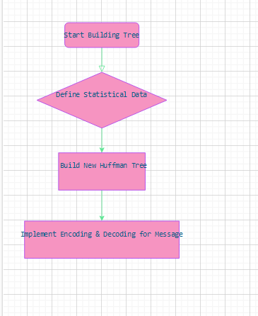

These algorithm structures provide a step-by-step breakdown of each function's implementation.

5.1 Initialization (function 1):

5.1.1 the process of reading the character set size, characters, and weights from the terminal.

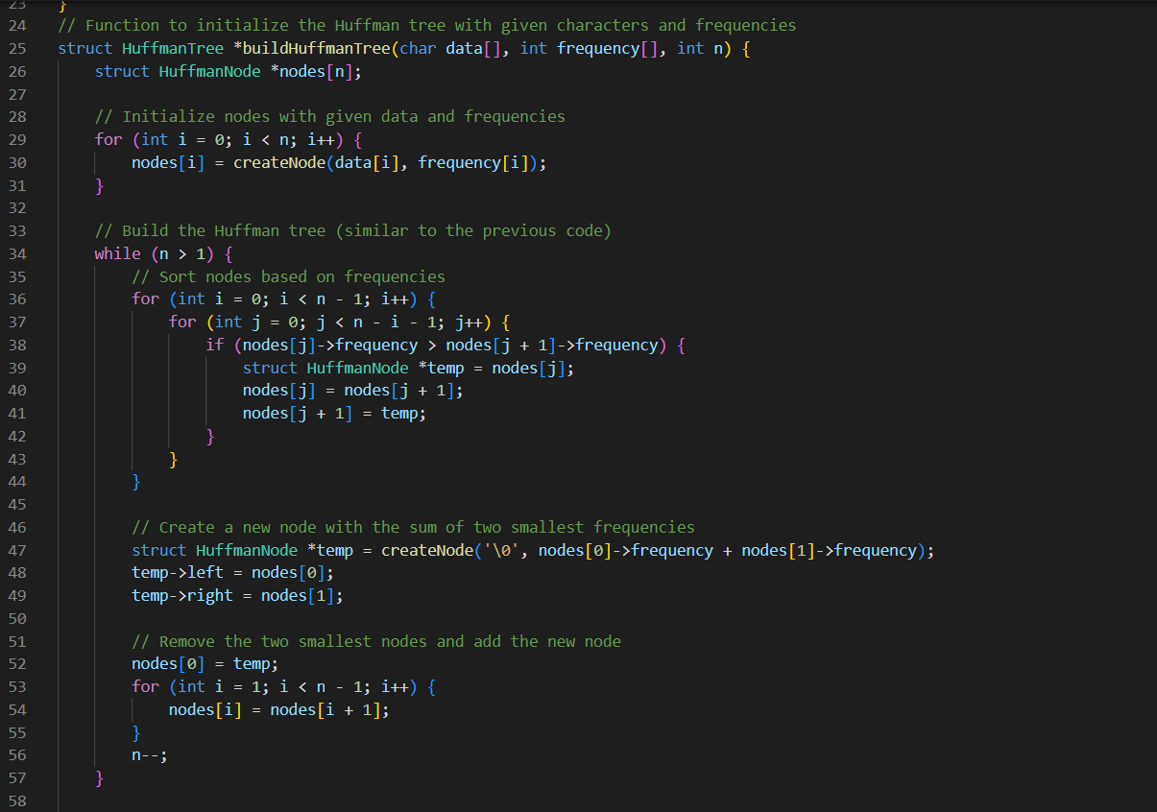

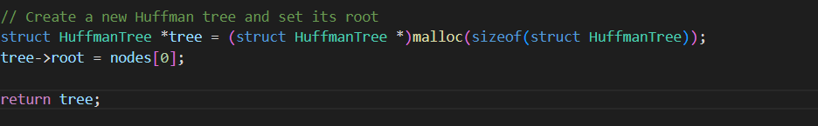

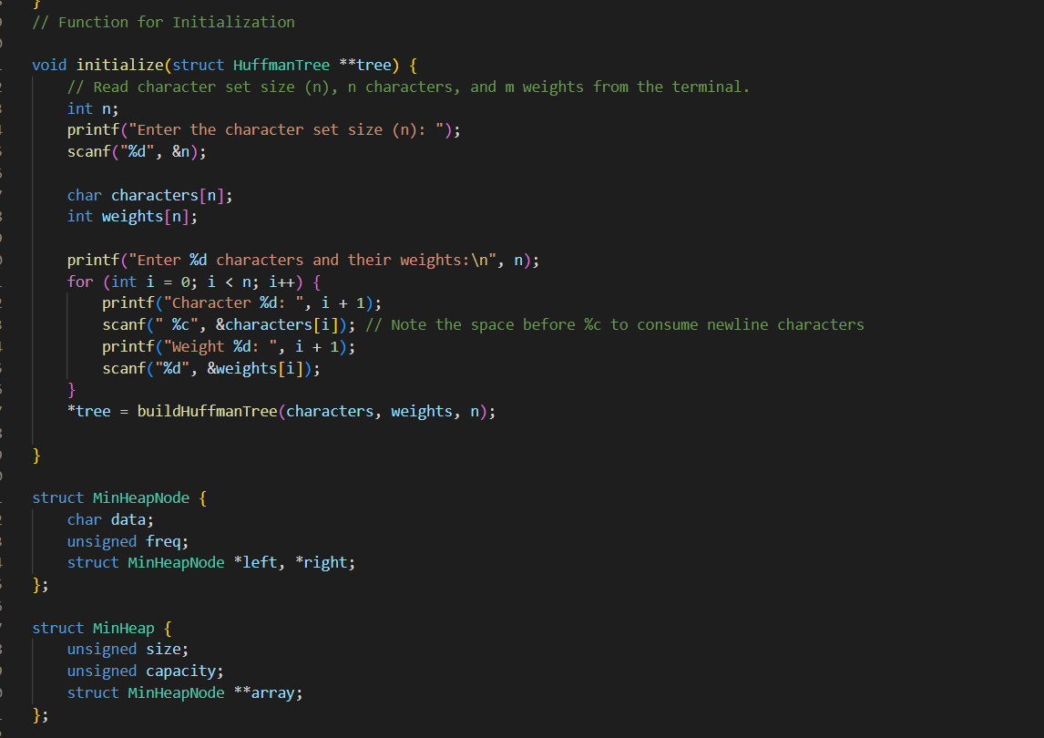

When reading the character set size, characters, and weights from the terminal to establish the Huffman tree, the program follows these steps. First, it prompts the user to input the character set size (n), which represents the number of unique characters that will be used in encoding and decoding. Next, it asks for the n characters themselves and m weights associated with each character. These weights indicate how frequently each character occurs in the given data or text.
To ensure accurate data input, validation is performed on the user's input. The program validates that the provided inputs meet the expected format and constraints. It checks if the character set size (n) matches the actual number of characters entered and verifies that the number of weights (m) is appropriate.
After validating user input, data structures are initialized to store both the character set and their corresponding weights. These data structures can be arrays, lists, or other suitable formats depending on programming requirements.
Finally, all inputted characters and their respective weights are stored in these initialized data structures for further processing within the program.
By following these steps, users can effectively provide input for establishing a Huffman tree based on their desired character set and associated frequencies.

5.1.2 Establishing the Huffman Tree :

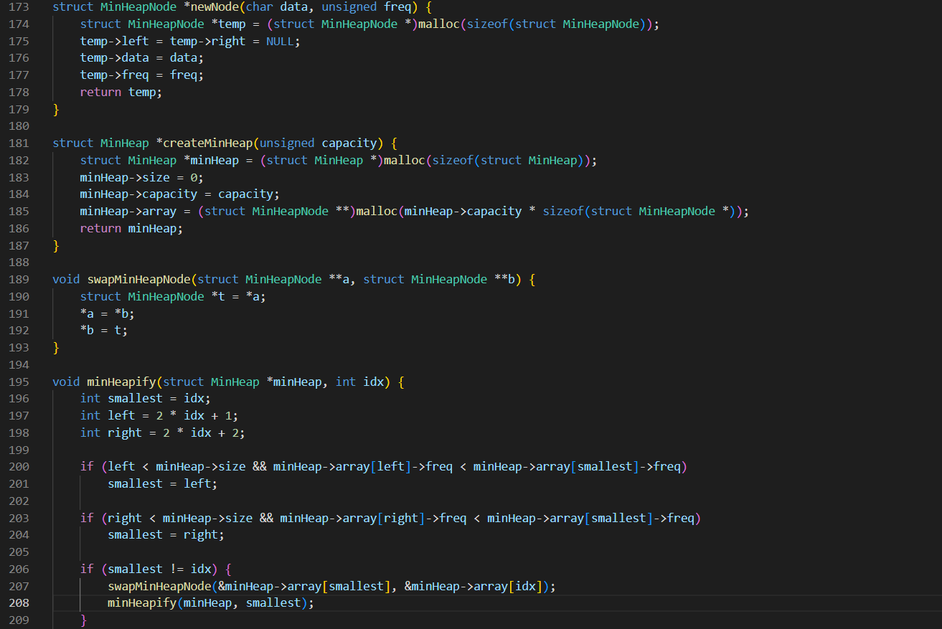

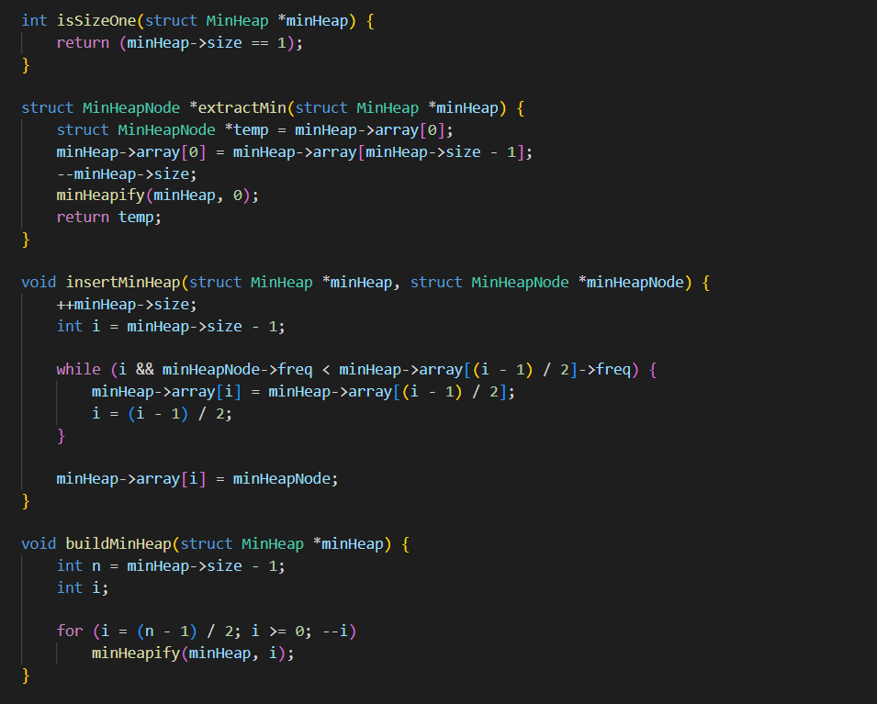

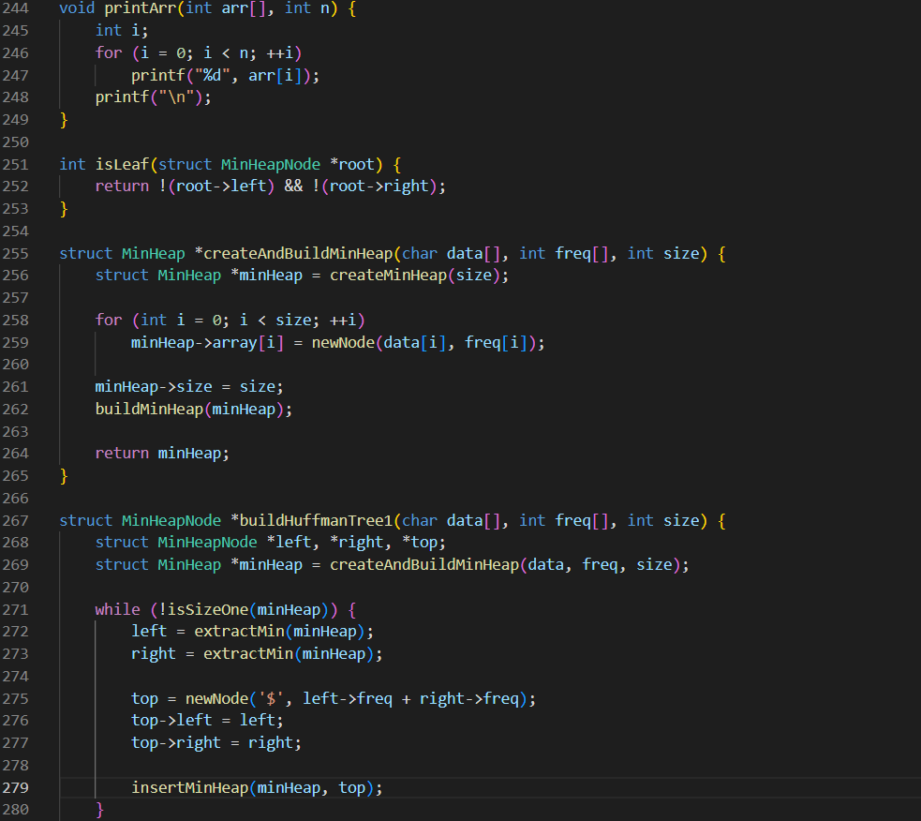

Frequency Calculation: The frequency of each character in the input data is calculated. This information is crucial for building the Huffman tree as it determines the priority of characters based on their frequencies.
Min-Heap: A min-heap data structure is created to prioritize characters based on their frequencies. This ensures that characters with lower frequencies are given higher priority during tree construction.
Node Creation: Leaf nodes are created for each character in the input data. Initially, each leaf node represents a single character along with its corresponding frequency.
Huffman Tree Construction: The process of constructing the Huffman tree begins by extracting two nodes with the lowest frequencies from the priority queue or min-heap. These nodes are combined to create a new internal node, where its frequency is equal to the sum of the frequencies of the extracted nodes. The new internal node is then inserted back into the priority queue or min-heap.
tree Traversal: Once the Huffman tree is constructed, it needs to be traversed to assign binary codes to each character based on their position within the tree structure. Typically, left branches represent '0,' and right branches represent '1.' These binary codes will be used for encoding and decoding purposes.
5.1.3 Saving the Huffman Tree in 'hfmtree' File:
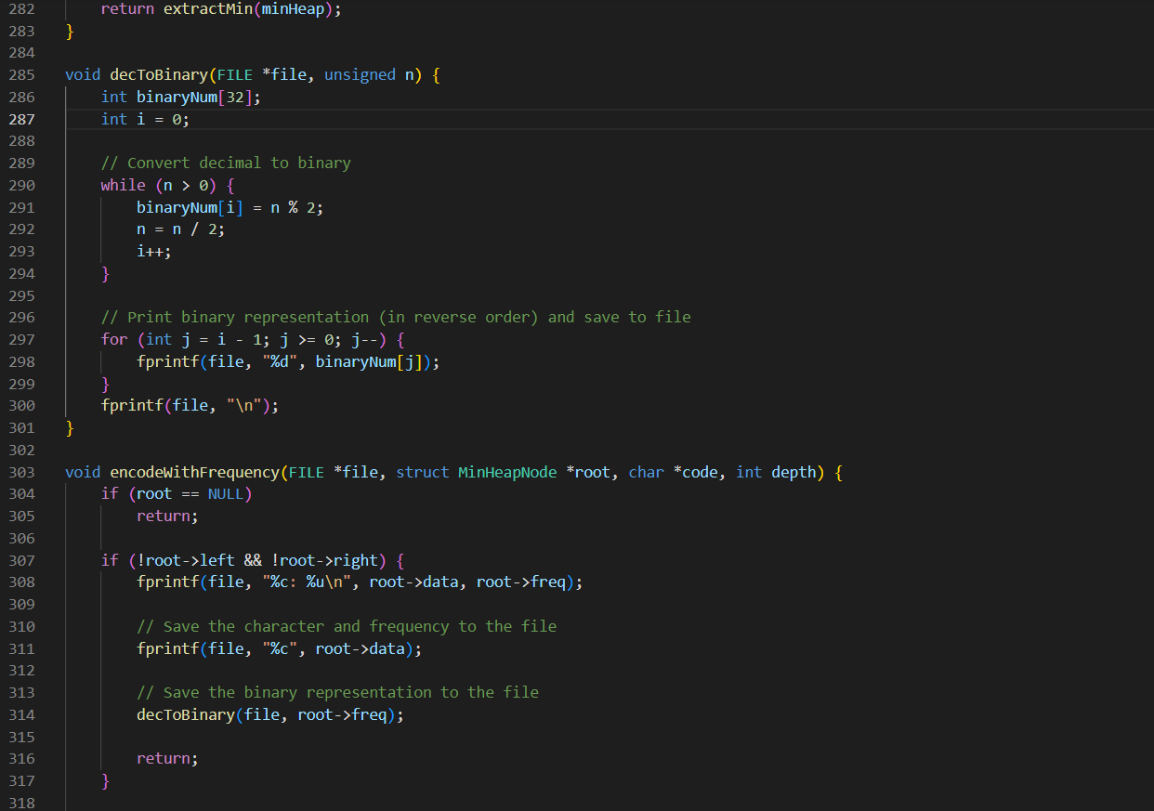
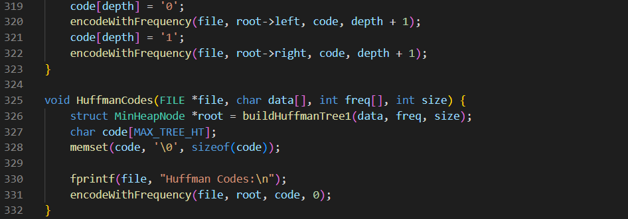
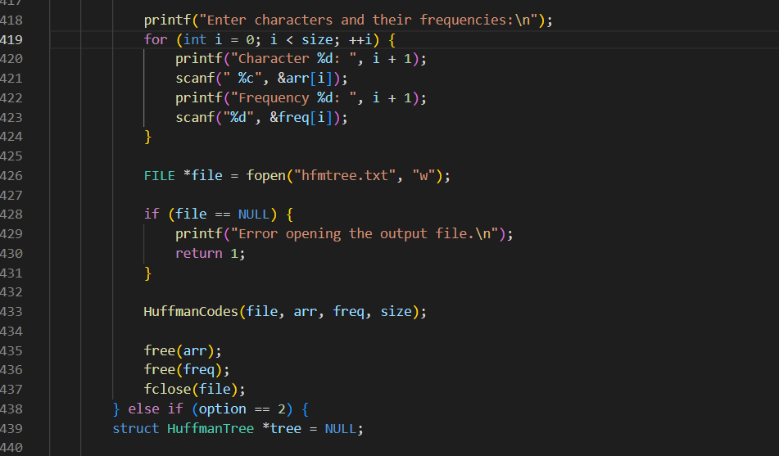
To implement the necessary functions for the Huffman encoding and decoding system, the following steps are involved:
Firstly, the program opens the 'hfmtree' file for writing. This file will be used to store the serialized Huffman tree data.
Next, the Huffman tree is serialized into a format that can be easily stored in the file. This serialization process typically involves traversing the tree structure and recording information such as node connections and binary codes assigned to each character.
Once the Huffman tree is serialized, the program writes this serialized data to the 'hfmtree' file. This ensures that all necessary information about the Huffman tree is saved for future use during encoding and decoding processes.
Finally, after successfully writing to the file, it is important to close it properly using appropriate file closing operations. This ensures that all changes made to the 'hfmtree' file are saved and resources are freed up.
5.2.1 explain about encoding using Huffman Algorithms (function2) :
Firstly, it checks if the Huffman tree, a crucial data structure for encoding and decoding in Huffman coding, is already present in memory. If not, it retrieves the Huffman tree by reading it from the 'hfmtree' file. The Huffman tree represents the mapping of characters to their corresponding binary codes.
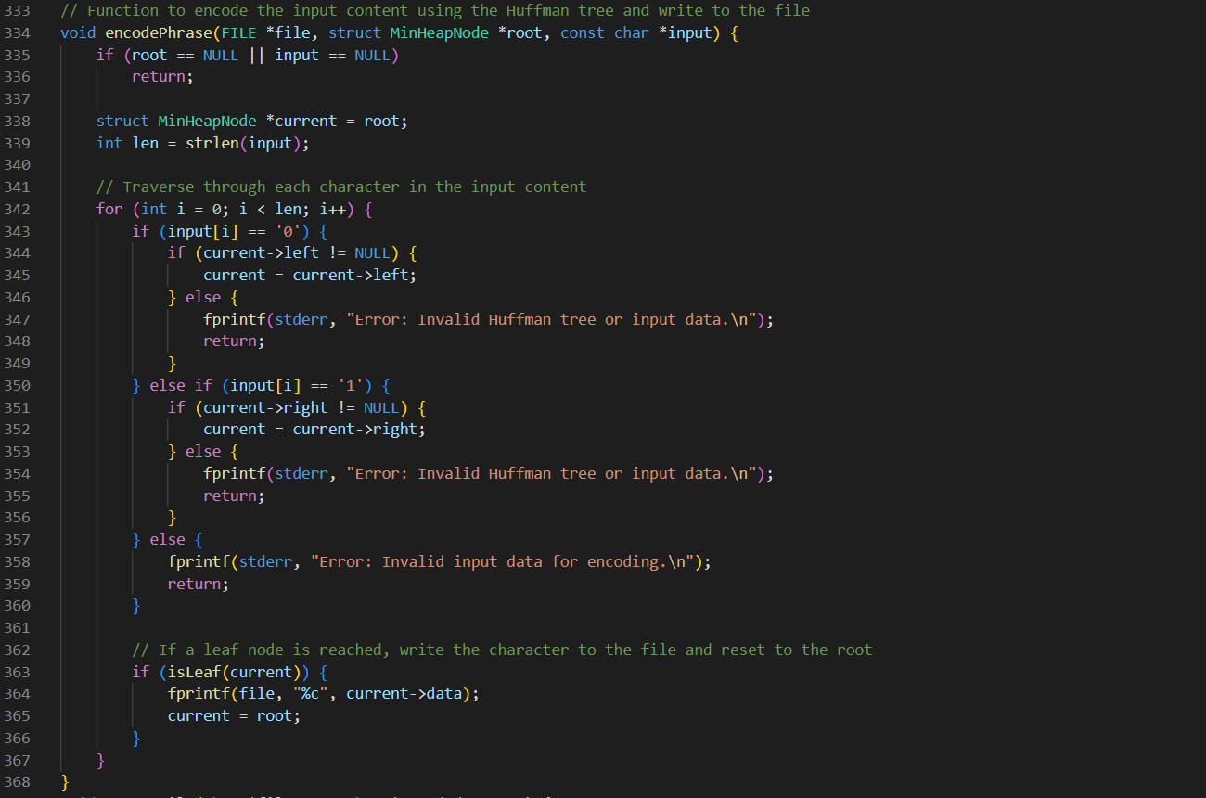
Next, it opens two files, 'tobetras' for reading and 'codefile' for writing. 'tobetras' contains the data to be encoded, while 'codefile' will store the binary codes generated during the encoding process.
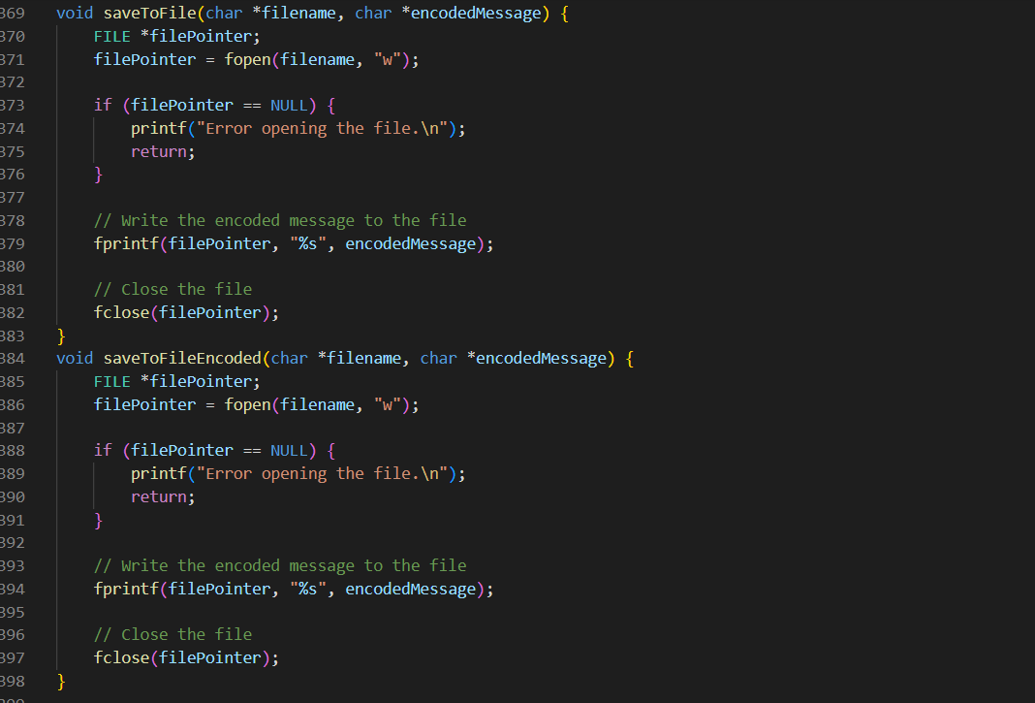
The function then proceeds to read each character from 'tobetras' file one at a time. For each character, it traverses the Huffman tree to determine the binary code associated with that specific character. Subsequently, it writes the obtained binary code to the 'codefile'.
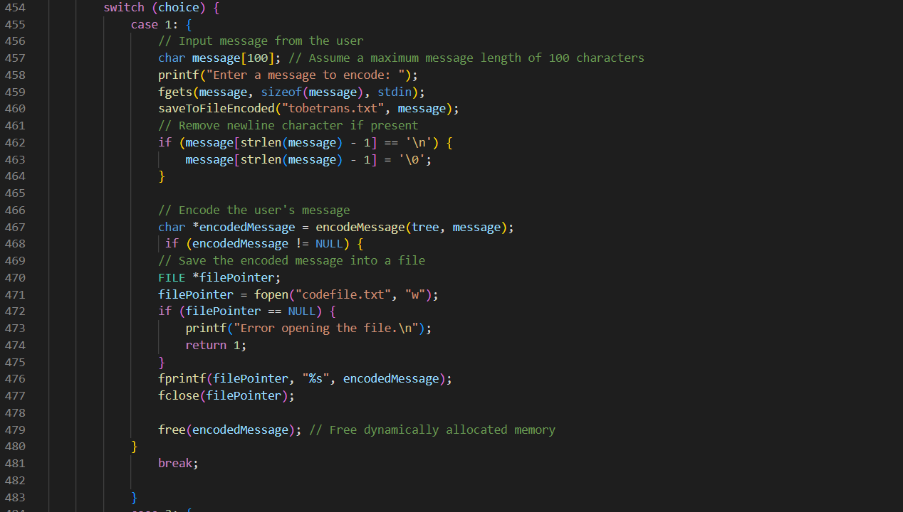
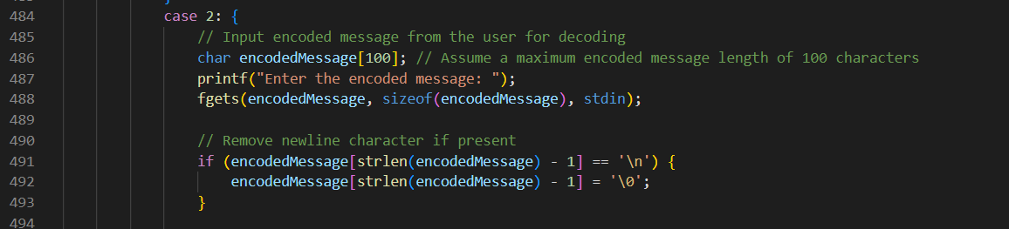
This process is repeated iteratively until all characters in 'tobetras' have been encoded and their corresponding binary codes have been written to 'codefile'. Finally, the function closes both the 'tobetras' and 'codefile' files, completing the encoding process.

5.2 explain about decoding using Huffman Algorithms with C programming (function 3):

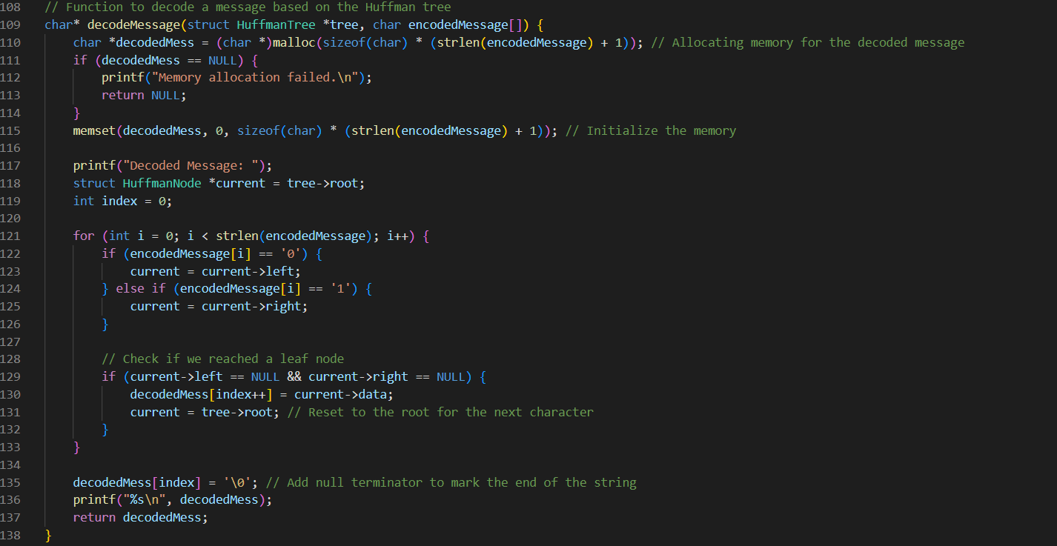
1. Using the Huffman Tree, decode 'codefile': - The initial step in decoding is reading the data from the 'codefile.' The encoded data is contained in this file, where each Huffman code represents a specific character based on the previously built Huffman tree.
2. Decode using the Huffman Tree: - The software decodes the encoded data using the Huffman tree, which is either already in memory or retrieved from the 'hfmtree' file (if not already in memory). The mapping between Huffman codes and original characters is provided by the Huffman tree.
3. Reconstruct Original Text: The program reconstructs the original text character by character as it traverses the encoded data using the Huffman tree. Huffman codes are gradually replaced with their matching characters, re-creating the original material.
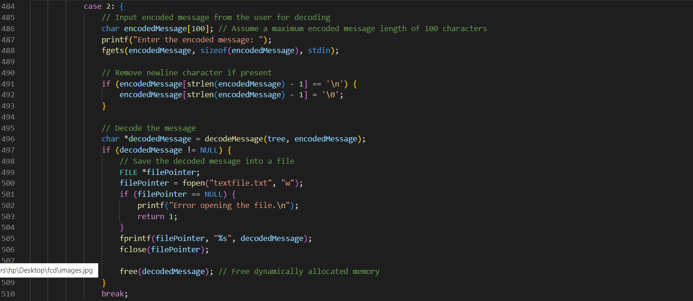
4. Save Decoded Output to 'textfile': - The final step is to save the decoded results, representing the original content of the 'codefile,' into the 'textfile.' This file captures the decompressed and restored version of the initial text, completing the decoding process.
5.3 Building Huffman tree with statistic data in C programming using Data structures function (4):
The "Build Huffman Tree with Statistical Data" stage entails creating a new Huffman tree based on statistical data and then performing message encoding and decoding.
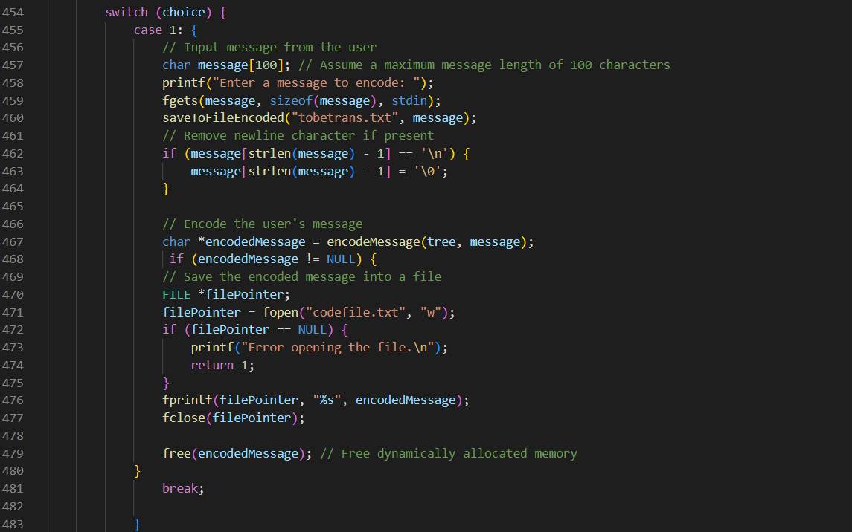

1. Initialize the Statistical Data:The first step is to collect statistical information about the character set and its frequency. This data could be pre-defined or derived from evaluating a particular text. It looks to be specific data presented in a table in your case.
2. Construct a New Huffman Tree: The application creates a new Huffman tree based on the statistical data. This entails constructing nodes for each character and weight pair, then repeatedly combining nodes with the lowest frequencies until a single root node representing the entire Huffman tree is generated.
3. Utilize Encoding for a Specific Message:- Following the construction of the new Huffman tree, the software implements encoding for a specific message. The message in your case is "This Program IS MY FAVORITE." The software traverses the tree to locate the Huffman codes for each character in the message, resulting in the encoded text representation.
4. Implement Decoding for the Same Message:- After encoding, the program implements decoding for the same message. Using the freshly generated Huffman tree, the program decodes the encoded message to the original text. This validates the Huffman tree as well as the encoding-decoding operation.
5. Save Results (Optional): Depending on your needs, you may save the freshly constructed Huffman tree to the 'hfmtree' file. for future use. This ensures that the tree can be reused without rebuilding when encoding or decoding similar messages in the future.
04.6 Implementation Tips : organizing and designing the program :
The "Implementation Tips" section offers advice on efficiently planning and structuring the software. Each tip is explained in detail below:
1. Divide the Program into Three Modules (Initialization, Coding, and Decoding):- Divide the program into three distinct modules, each of which is responsible for a certain task:
- The initialization process: Reads the character set size, characters, and weights, creates the Huffman tree, and stores it to 'hfmtree.'
- Coding: Uses the Huffman tree to encode the 'tobetras' file, with the option to read the tree from 'hfmtree' if it is not in memory.
- Decoding: Uses the Huffman tree to decode the 'codefile' and stores the results to 'textfile.'
2. Design the Program with a Menu Mode for User actions: - Create a menu-driven interface that allows users to select from a variety of actions. This is a possibility. This could be accomplished by displaying a menu to the user and prompting them to select an option. ''' For instance: ''' Menu:
1. Begin by initializing
2. Encoding
3. Decoding
4. Create a Huffman Tree Using Statistical Data.
5. Exit .
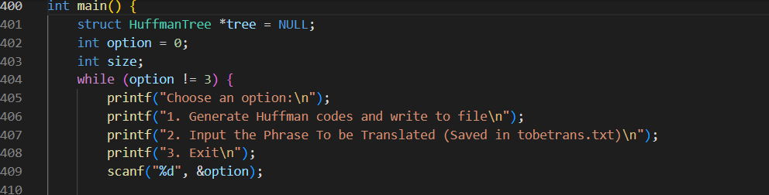
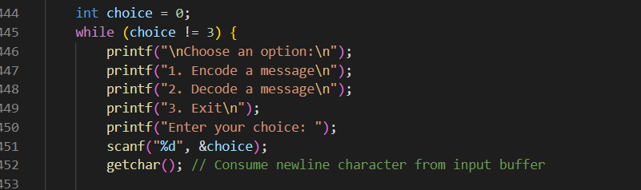
3. Ensure Disk File Data is Read Only Once per Each Execution: - Create a technique to ensure that data from disk files is read only once per program execution. For instance, during the initialization step, read the required data and store it in memory for later usage. This reduces the number of redundant file reads, increasing efficiency.
4. If necessary, perform an initial normalization operation during program installation: - If the program's character set and weight data are fixed, execute an initial normalization operation during program installation. This might happen. involve setting up default values or pre-processing the data to streamline the program's execution. This ensures that essential data is readily available when the program runs, contributing to smoother operations
04.7.1RESULT OF TEST :
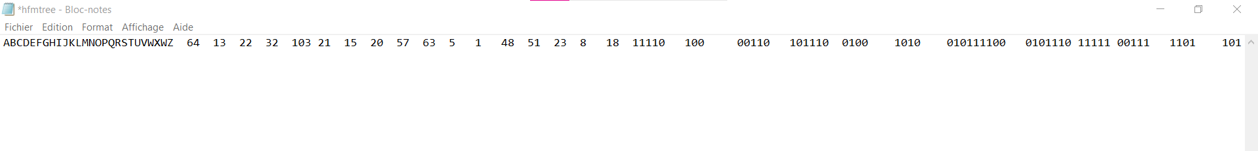
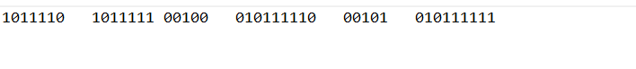
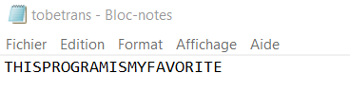
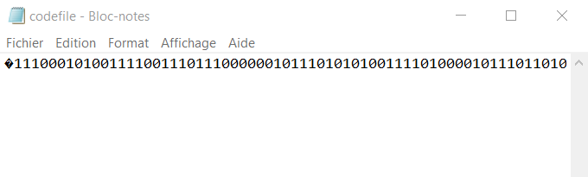
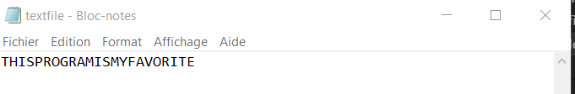

04.8 Conclusion :
This study focuses on the implementation and optimization of Huffman encoding in order to improve the efficiency of information communication. The project's purpose is to use Huffman trees and data structures to improve channel use, reduce transmission time, and lower costs. The research investigates efficient Huffman tree construction strategies for better compression efficiency as well as dynamic Huffman coding situations for adaptability to changing data frequencies. It also looks at mistake detection and correction methods for improving Huffman coding and decoding resilience. The employment of the Huffman algorithm in this methodology has yielded promising outcomes, such as better compression efficiency, resilient adaptation to dynamic .conditions, and error resilience. The practical implications and significance of data compression are highlighted in this paper, which significantly advances the field.

HIND EL KETTENI 229J81
REFERENCES
Reference intro(1) ACM Comput. Surv., Vol. 1, No. 1, Article 1. Publication date: June 20 Huffman coding , ALISTAIR MOFFAT, The University of Melbourne, Australia
Reference intro exemple” 计算机考研 玩转 数据结构 p157”
https://web.stanford.edu/class/archive/cs/cs106b/cs106b.1176/assnFiles/assign6/huffman-encoding-supplement.pdf
https://people.eng.unimelb.edu.au/ammoffat/abstracts/compsurv19moffat.pdf
https://worldwidescience.org/topicpages/h/huffman+coding+tree.html#
BOOK of Data structures and Algorithm analisis in c (Mark Allen Weiss)
数据结构与算法C语言篇慕课版 p104

